|  |
| --- |
| NAME: Apoorva H P  USN: 4AL17CS011 |

1)

Student (snum: integer, sname: string, major: string, level: string,age: integer)

Class (name: string, meets at: string, room: string, d: integer)

Enrolled (snum: integer, cname: string)

Faculty (fid: integer, fname: string, deptid: integer)

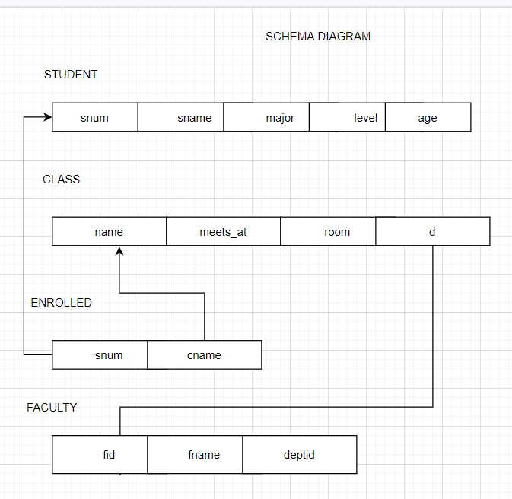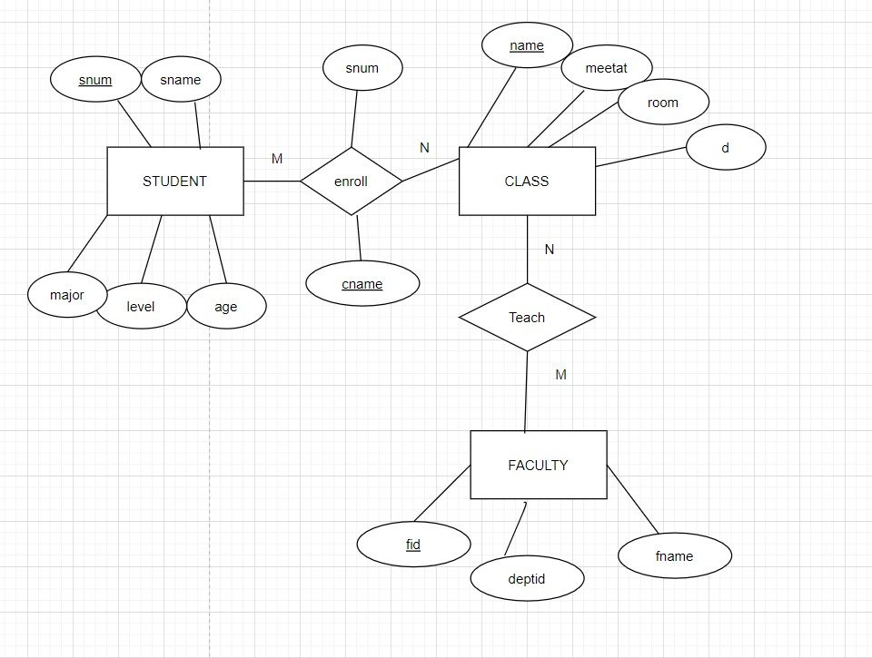

2)

BRANCH(branch-name:string,branch-city:string,assets:real)

ACCOUNT(accno:int,branch-name:string,balance:real)

DEPOSITOR(customer-name:string,accno:int)

CUSTOMER(customer-name:string,customer-street:string,city:string)

